# Mood sheet

## Jail

* No daylight, low light, gloomy, blue
* Cells are built directly next to each other
* Metal and stone combination
* Not fancy
* Security systems exist (cameras and guards)
* The offices, evidence-, and security rooms have a stronger security (more cameras)

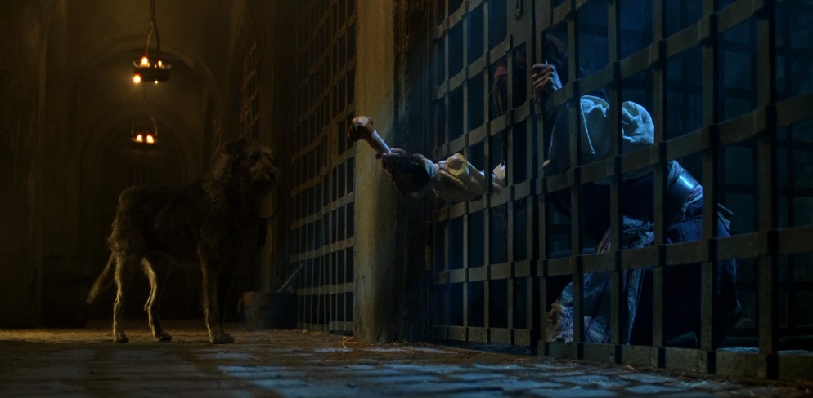

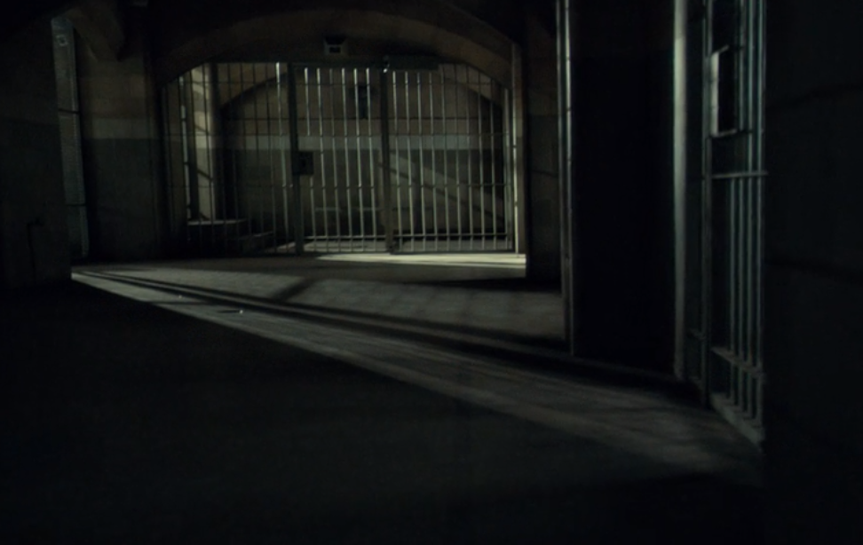

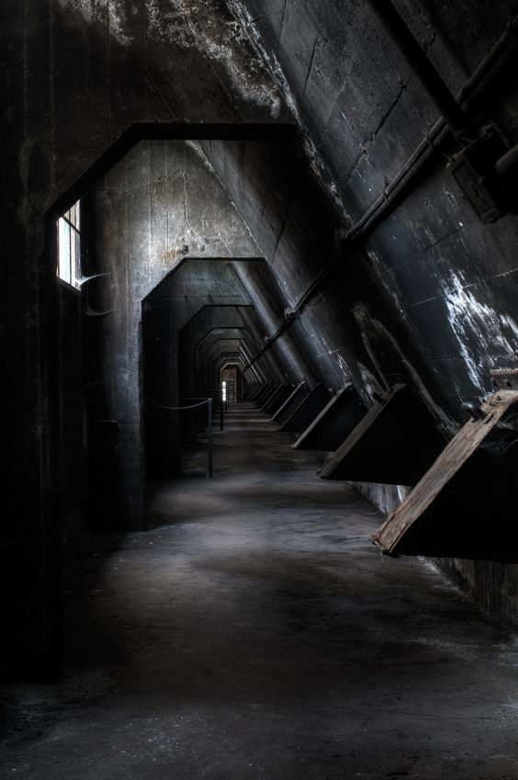

## Low (slums)

* depiction of poverty, blue, sad, places of ‘hope’ like little fireplaces etc.
* Broken down buildings, homelessness, high crime rate
* Streets are filled with people and heavily policed
* Clothes; if people own them at all, are mostly torn and dirt
* Colder than in the pictures

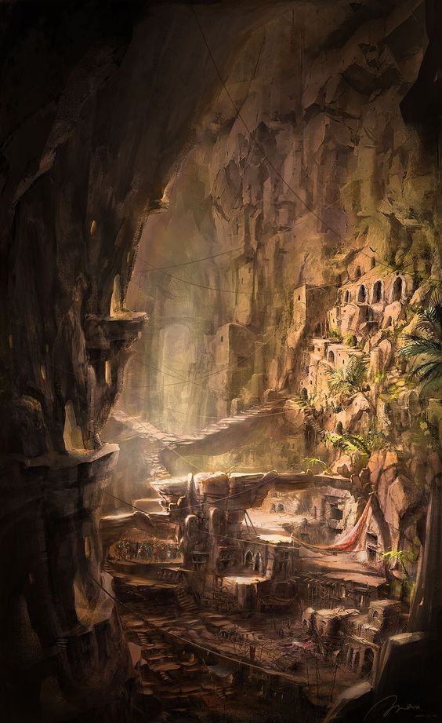 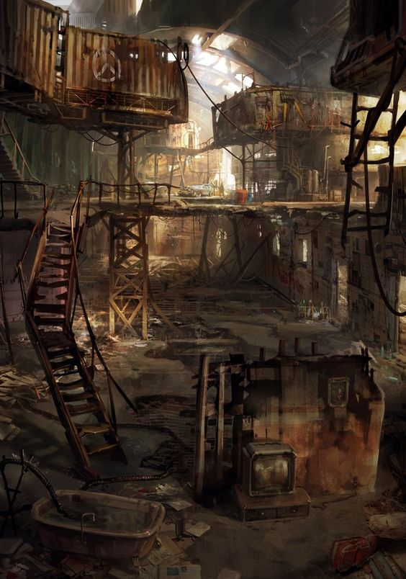

## Lab (hide-out)

* Broken down building
* Blueprints
* Several prototype-bodies of the robot
* Small signs of grandpa working there
* Matrasses, blankets, improvised kitchens (…)
* Signs of street kids living there
* Like in the pictures, but warmer, place of hope in a hopeless world

